Water Pollution Lab—Water Treatment Simulation
Day 1: Background and Research—Why is water important?
https://www.youtube.com/watch?v=u_kurRd1TuM – What does water pollution look like and why should we care?
http://bluelivingideas.com/2010/04/01/clean-water-human/ –How much water is there?
http://www.water-pollution.org.uk/causes.html – How does water get polluted?
https://www.youtube.com/watch?v=RTtwlT-nKGY – How does nature filter water? (video)
History of Water Treatment
Water has always played a prominent role in human civilization. When people first began settling in one place and growing crops for sustenance, it was invariably near water sources like rivers, lakes, or groundwater springs. Water was needed for drinking, preparing food, bathing, cleaning, irrigating crops, and a variety of other tasks, so it was important to have ready access to this resource. The water sources used for supplying water were not always clean however, and treating drinking water to improve smell, taste, clarity, or to remove disease-causing pathogens has occurred in one form or another throughout recorded history.

Read and take notes (on page 2 of this packet): Water Filter Media Facts

Drinking Water Treatment Process
Now that you are familiar with drinking water treatment, let's examine modern methods in greater detail. In general, the treatment of drinking water by municipal water systems involves a few key steps:

Aeration: | The water is mixed to liberate dissolved gases and to suspend particles in the water column.
Flocculation: | The materials and particles present in drinking water (clay, organic material, metals, microorganisms) are often quite small and so will not settle out from the water column without assistance. To help the settling process along, "coagulating" compounds are added to the water, and suspended particles "stick" to these compounds and create large and heavy clumps of material.
Sedimentation: | The water is left undisturbed to allow the heavy clumps of particles and coagulants to settle out.
Filtration: | The water is run through a series of filters, which trap and remove particles still remaining in the water column. Typically, beds of sand or charcoal are used to accomplish this task.
Disinfection: | The water, now largely free of particles and microorganisms, is treated to destroy any remaining disease-causing pathogens. This is commonly done with chlorination (the same process used to eliminate pathogens in swimming pools), ozone, or ultraviolet radiation. The water is now safe to drink and is sent to pumping stations for distribution to homes and businesses.
Supplemental resources can be found by accessing the articles listed below.
Drinking Water Treatment

A detailed examination of municipal drinking water treatment methods: United States EPA
Drinking Water and Health: What You Need to Know!

Overview of potential contaminants in drinking water and related health effects: United States EPA

Water Filtration in Nature: | The Control Filter:
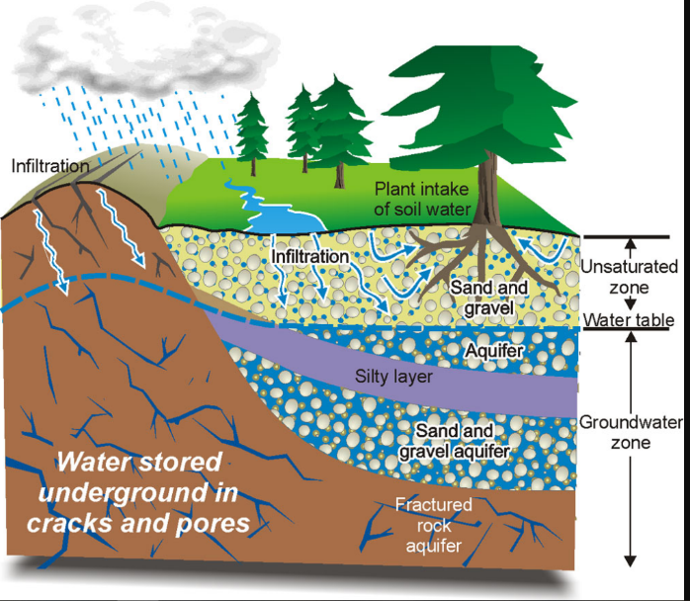

Notes:

My Filter:
Key:

WHAT did you change? | WHY did you change it?

Day 2:

Activity: Simulated Drinking Water Treatment Plant
In this activity we’ll be treating "contaminated" water to observe firsthand the steps involved in purifying water for human consumption. The activity will use everyday items to carry out the steps in drinking water treatment and you will record changes in the water’s properties as the process progresses. First you will record the appearance and odor of untreated water as it moves through the various steps. Then you will find the pH change as the water is cleaned. Finally the turbidity which describes the clarity or “muddiness” of a water sample will be measured by examining the transmission of light through the water sample using colorimeters.
Materials: 2 L bottle, beakers, water sample, colorimeter, cuvette, pH paper, pipette, well plate, forceps
- Hear the story of the contamination of drinking water and create contaminated water sample. Record data for section labeled “Analysis of Contaminated Water”
[WARNING]: The water used in the experiment is not suitable for drinking at any stage in treatment. Hence, do not consume the water under any circumstances.

Analysis of Contaminated Water
Cap and shake the container of contaminated water for 30 seconds, and pour 1 L into one of the empty beakers. Describe the appearance and odor. Determine pH with pH paper. Use the colorimeter to find the turbidity of the water sample.
Appearance
Odor
pH

Colorimeter

Day 3:
Purpose: Complete the steps of water treatment including creating a water filtration system to effectively clean the water sample.
- Complete Step 1: Aeration, Step 2: Coagulation, and Step 3: Sedimentation collecting appropriate data at each step.
Step 1: Aeration
Pour the water sample into a 2 liter bottle. Cap the 2 liter bottle and aerate the water by shaking it vigorously for 30 seconds. Pour the water into one of the beakers and then pour the water back and forth between the beakers 5 times. Once you have done this, describe the appearance, odor, and find the pH (Universal indicator) and turbidity of the water (using the colorimeter).

Appearance
Odor

pH
Colorimeter

Step 2: Flocculation/Coagulation
The water sample should still be in a beaker. Add 20 grams of alum crystals to the container and stir gently for 5 minutes. The alum will act as a coagulant and bind with the particles suspended in the water. Describe what happens to the appearance of the water during the 5 minutes. Determine pH with universal indicator. Use the colorimeter to find the turbidity of the water sample. (This will also be your “Time 0 min” data for the Sedimentation step when you graph.)
Appearance
Odor
pH
Colorimeter

Step 3: Sedimentation
Leave the container and cuvette undisturbed for 20 minutes and record observations of the water's appearance and take turbidity readings with the colorimeter at 5-minute intervals. At the end of 20 minutes, decant and store your water sample in a sealed 2-L bottle.
Time (min) | Appearance | Colorimeter reading | pH
5
10
15
20
Day 4 and 5:
Hypothesis: (based on research AND filtration design- refer back to page 2 of packet)
If ___, then ___ because…

Step 4: Filtration
From here, list your materials and procedures of how you plan to create your filtration apparatus.
Materials:

Procedures:

Procedures continued:

Results:
Property | Experimental |  |  | Control
 | Trial 1 | Trial 2 | Avg. | Trial 1 | Trial 2 | Avg.
Appearance |  |  | X |  |  | X
Odor |  |  | X |  |  | X
pH

Colorimeter

Cost |  |  |  | $59.35
Show work for cost calculation:

Step 5: Disinfection
The final step in the process, the elimination of any remaining microorganisms, will not be done in this exercise. This is normally an important step in the process, but as the water is not to be consumed and disinfection methods can be dangerous outside of controlled conditions, this step will not be done in this exercise.
Graph: Plot the changes in the appropriate values from contamination through all the steps of treatment.

Day 6:
Analysis/Discussion:
Claim: (Is the hypothesis supported or rejected by the data?)

Evidence 1 (Data Comparison):

Reasoning 1 (Apply reseach):

Evidence 2 (Graphical Analysis):

Reasoning 2 (Apply research):

Evidence 3 (You pick):

Reasoning 3 (Apply research):

Conclusion:
Claim: (Is the data reliable (experimental error, data consistency, outliers) and valid (test what you intended to test) in supporting the hypothesis?)

Evidence 1 (Reliability):

Evidence 2 (Reliability):

Evidence 3 (Validity):

The experimental design can be improved if the experiment were repeated. Cite two ways to improve the experiment and explain how they will improve the reliability and validity of the data.
Improvement 1 (reliability):

Improvement 2 (validity):

Control Filter design: working from bottom to top: 2-L cut in half, 2 coffee filters stacked, 99.7 grams of sand, 121.2 grams of pea gravel, 126.8 grams of river rock, 192.9 grams of marble rock. Total cost: ______$59.35_________
Item | Cost | Item | Cost
Coffee filters | 2 cents each | Panty hose | 50 cents each
Sand | 2 cents/gram | Charcoal | 30 cents/ gram
Pea gravel | 5 cents/gram | Cotton balls | 3 cents each
River rock | 10 cents /gram | Baking Soda | 20 cents/ gram
Marble rock | 20 cents/gram | Popsicle sticks | 15 cents/ each
Pool Shock | 20 cents/ gram | Cheese Cloth | 50 cents/ foot

