Ionic Bonding Puzzle Activity (for absent students)
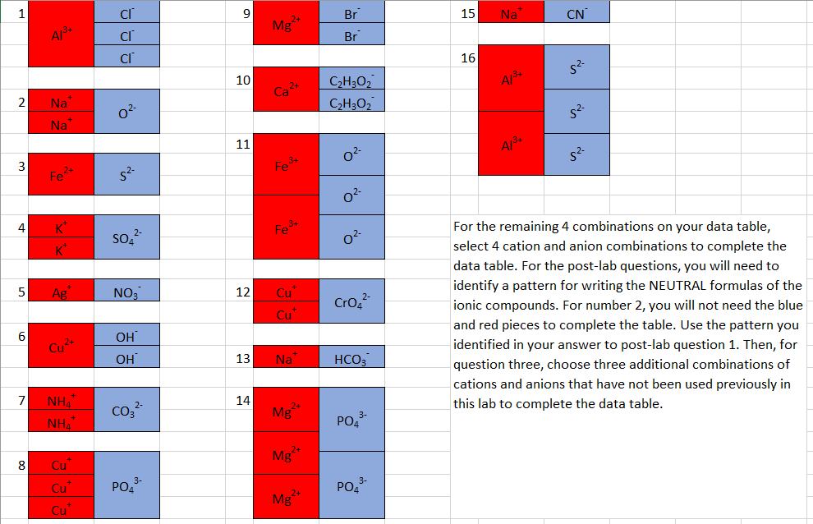
**Additional monatomic and polyatomic ions can be found on the BACK of your color-coded periodic table that you should still have in your binders and/ or folders for chemistry. They are also included on the following page if you have misplaced them.

