Chromatography Tie-Dye 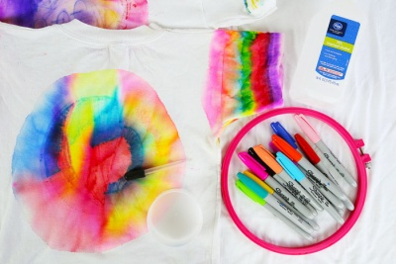
Introduction: Tie dye has been used since 500 AD. The earliest tie dye records were in Peru and Asia. The name “Tie Dye” was actually coined in the early 1960’s because the clothes were literally “tied and dyed”. We will be using sharpies and isopropyl alcohol to tie dye our fabric. But why does isopropyl alcohol lead to the “tie dye” effect?
#1: Why must we use 100% cotton? Why can’t synthetic materials be used? Predict.
__________________________________________________________________________________________________
#2 Why do we have to use sharpies and not crayola markers? Predict.
__________________________________________________________________________________________________
#3 Why do we have to use isopropyl alcohol and not water to create the “tie dye” affect? Predict.
__________________________________________________________________________________________________
#4 What do you think the alcohol will do to the sharpie on your fabric? Why will that happen? Predict. ____________________________________________________________________________________________________________________________________________________________________________________________________
Term | Definition | Application to Tie Dye
Polar substance
Nonpolar substance
Diffusion
Chromatography
Solution

Solute

Solvent

The Science Behind the Fun: Pigments are molecules that give things color. The pigments in permanent markers are trapped in ink compounds that are insoluble in water. However, if you add a solvent, like rubbing alcohol to permanent markers, it dissolves the ink. As the alcohol moves through the cloth you are decorating, it carries the pigments along with it. Small pigment molecules move faster than big ones, so the colors sometimes separate into their different color components as they move through the cloth. The alcohol evaporates into the air, leaving the ink in the fabric, and since it is still insoluble in water, it won’t come out when you wash it.
Procedures:
- Place cardboard on the inside of the cloth. (Separating the front and back.)
- Use permanent colored markers to add small dots, lines, or designs to the cloth wherever you desire.
- Use a dropper to place 5–10 drops of alcohol on the dots, lines, or designs.
- Wait a few minutes for the alcohol to soak the colors and observe.
- Repeat steps 1–4 several times on different areas of the cloth.
- Blow dry your cloth. If not completely dry, you can leave it and come back later to get it.
- AT HOME: Rinse with cool water several times, wash in the rinse cycle with NO detergent, and then you can wash like normal.
Analysis and Conclusion:
Why does isopropyl alcohol cause sharpies to “tie dye” your fabric? (Use the terms: polar compounds, nonpolar compounds, solute, solvent, chromatography, and diffusion in your response.) Underline the terms when used!!!
________________________________________________________________________________________________________________________________________________________________________________________________________________________________________________________________________________________________________________________________________________________________________________________________________________________________________________________________________________________________________________________________________________________________________________________________________________________________________________________________________________________________________________________________________________________________________________________________________________________________________________________________________________________________________________________________________________________________________________________________________________________________________________________________________________________________________________________

